**Sprint 4**

**Agile Board - Work View captured in JIRA**

**Example 1 of 4**

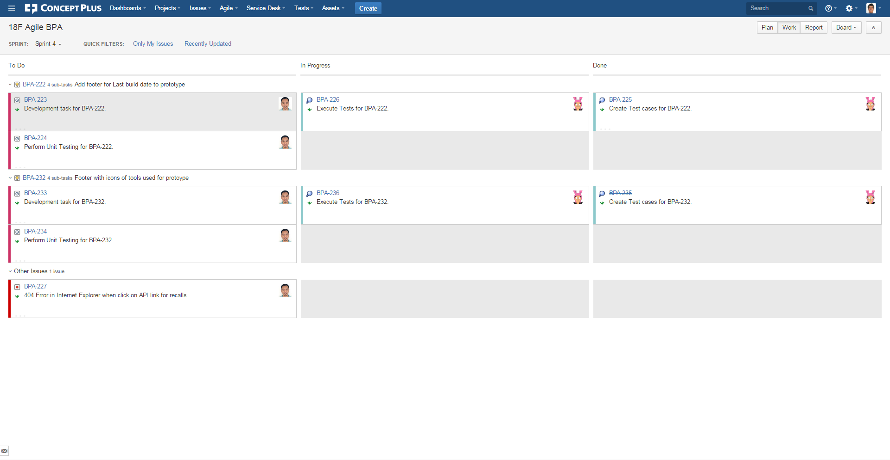

**Example 2 of 4**

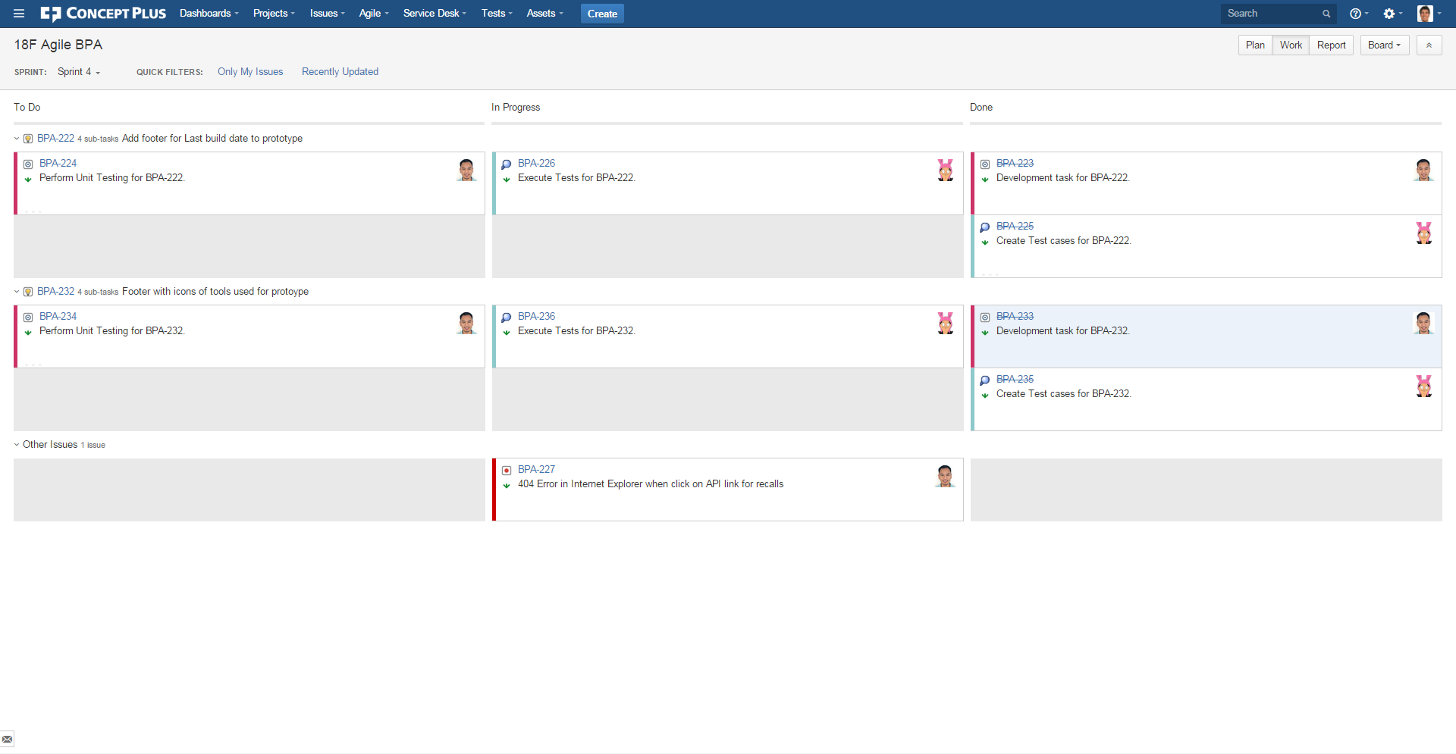

**Example 3 of 4**

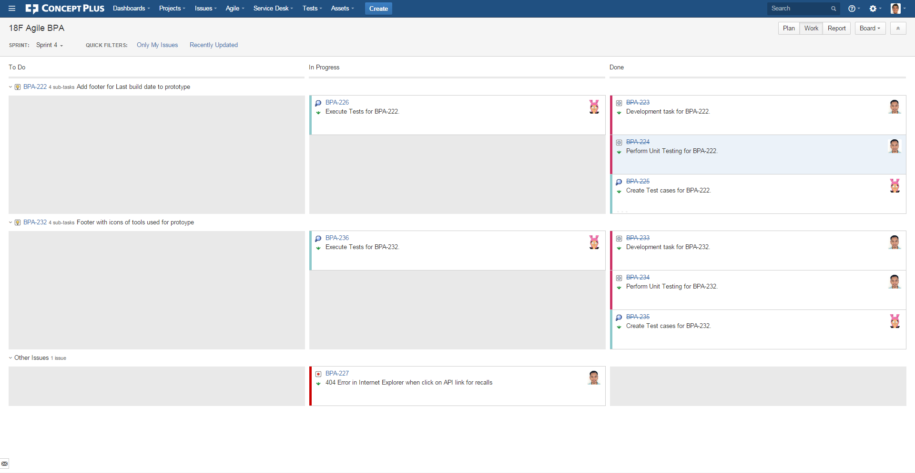

**Example 4 of 4**

